**Implementing Short-Form and Interactive Content:**

**A Strategic Proposal for Netflix**

**Team DART**

**TC**

**AS**

**DS**

**MRT**

# Table of Contents

Table of Contents 1

Part 1: Company Overview 2

Part 2: Identification of Strategic Problem or Opportunity 3

Part 3: Proposed Strategy 4

Short-form Content 4

Interactive content 4

Further Recommendations 4

Part 4: Strategic Alignment with Existing Business and Feasibility 6

Short Form Content 6

Interactive Content 6

Further Recommendations 7

Part 5.1: Opportunity Analysis 8

Short-Form Content Feasibility: 8

Interactive Content Feasibility: 8

Challenges: 9

Part 5.2: Regression Analysis 10

Part 6.1: Risk Assessment 11

Part 6.2: GenAI for Risk Assessment 12

Process and Insights: 12

Critical Reflection: 12

Part 7.1: Scenario Analysis 13

Best Case Scenario: 13

Worst Case Scenario: 13

Part 7.2: GenAI for Scenario Analysis 14

Process and Insights: 14

Critical Reflection: 14

Part 8: Conclusion 15

References 16

Appendices 18

Appendix 1: Figure 1 18

Appendix 2: Regression Results 19

Appendix 3: Table 1 20

Appendix 4: Table 2 21

Appendix 5: ChatGPT Conversation for Scenario Analysis GenAI Component 21

Appendix 6: ChatGPT Conversation for Risk Assessment GenAI Component 21

# Part 1: Company Overview

Founded by Reed Hastings and Marc Randolph in 1997, Netflix is a world leader in streaming entertainment, providing a wide range of content such as films, TV series, and original programming (Netflix Originals). With its headquarters in Los Gatos, California, Netflix operates in more than 190 countries. Netflix generates substantial revenues primarily from the monthly subscriptions paid by over 200 million worldwide subscribers as of 2021 (Netflix, 2024). When Netflix was first established in 1997, it started as a mail-order DVD rental service that catered to convenience-seeking consumers looking for a large selection of films cheaper than traditional rentals. Its 2007 move from rentals to streaming, which marked a significant change in its economic strategy, was made possible by early technology adoption (Keating, 2012).

Netflix is now well-known for its wide choice of original programming, which includes highly regarded shows like House of Cards, Stranger Things, and Narcos. House of Cards served as an example of its data-driven approach to content development, as user statistics informed the choice to re-create a UK series with comparable themes and release all episodes at once to accommodate binge-watchers. This creative approach strengthened its competitive edge and changed industry standards. Since then, the platform has developed more interactive content, including games based on popular TV shows and interactive movies like Black Mirror: Bandersnatch (Stoll, 2024; Amin, 2023). In addition to emphasizing individualized suggestions through data analysis, Netflix's commercial strategy strongly emphasizes collaborations with content producers, licensing studios, and technology companies like Amazon Web Services. Even with its achievements, the company still has to contend with issues such as heightened competition from Disney+, Amazon Prime, and HBO Max, growing production expenses, and consumer opposition to increases in subscription fees (Curry, 2024; Purdy, 2023).

Although Netflix remains at the forefront of the streaming market, its survival hinges on its ability to adjust to rivals, control expenses, and preserve customer loyalty in the face of a fragmented digital entertainment environment.

# Part 2: Identification of Strategic Problem or Opportunity

Netflix's success relies on its subscriber base. This dependence became apparent in 2022 when the company lost 970,000 subscribers, causing a $50 billion drop in its market cap. As the BBC highlighted, "As pre-pandemic habits return, Netflix has struggled to attract new and maintain the loyalty of existing members, especially as the rising cost of living leads to people cutting back" (Sherman & Clayton, 2022). At the same time, competition from Amazon Prime Video and Disney+ continues to grow, as shown in Figure 1 (Appendix 1). Adding to these challenges, Netflix's password-sharing crackdown in May 2024 led to significant churns.

To recover, Netflix introduced the ad-supported tier in late 2022 for price-sensitive customers, leading to a 70% increase in subscriptions within two years. Netflix’s original show, like Stranger Things, kept users engaged despite the backlash to the password policy. Bandersnatch also signaled a great success, with more than 90% of viewers engaged with the interactive story. According to Todd Yellin, that level of participation was the signal the streaming giant needed to “launch a whole new slate” of adult interactive content (Ramachandran, 2019). However, the company's decision to stop reporting subscriber numbers in mid-2024 has raised questions about stagnating growth. A deeper issue lies in changing viewer habits, particularly among younger audiences, who favor short-form content. “Gen Z [is] spending about three times as much in the short-form video than they are in OTT,” Krantz says (Koetsier, 2022). Platforms like TikTok, Instagram, and YouTube have capitalized on this trend, with over 50% of Instagram users purchasing products seen in Stories (Sheikh, 2024).

Netflix previously experimented with short-form content through its “Fast Laughs” feature but discontinued it. Revisiting and enhancing this feature could address changing audience preferences and strengthen engagement. Harry Gestetner, co-CEO of Fanfix, suggests short-form programming can attract younger viewers and guide them toward full-length content (Contreras, 2023). This format could also serve as a discovery tool, introducing users to new titles while generating insights into viewing patterns. At the same time, as demonstrated by Bandersnatch, Netflix’s success with interactive storytelling highlights the untapped potential of interactive content as a strategic opportunity. Interactive content immerses viewers in choice-driven narratives, and fosters repeat engagement. By embracing short-form and interactive content, Netflix can better adapt to evolving viewer habits, differentiate itself from competitors, and solidify its leadership in the streaming industry.

# 

# 

# Part 3: Proposed Strategy

### Short-form Content

With platforms like TikTok and Instagram Reels driving demand for bite-sized content, Netflix can leverage this trend by curating short-form videos, such as highlights or previews, from its extensive library. These can be entry points to full-length content, encouraging deeper audience engagement. According to an Ofcom study in 2023, 38% of UK online adults watch short-form videos daily, with 68% of 15-24-year-olds engaging, compared to 14% of those aged 65+ (IAB UK, 2023). This adoption of short-form content highlights shifting viewer preferences and underscores the importance of adapting to these habits to remain competitive.

Integrating targeted advertisements within these videos presents an opportunity for Netflix to attract younger, ad-receptive audiences while diversifying revenue streams. Moreover, short-form content would generate critical user data, providing insights into audience preferences and behaviors that could inform future content strategies. This approach aligns with evolving consumer habits and strengthens Netflix’s ability to compete in a saturated market. If executed properly, it can enhance Netflix’s platform ecosystem, broaden its audience reach, and reinforce its premium brand identity.

### Interactive content

Building on the success of Black Mirror: Bandersnatch, an interactive episode of Black Mirror where viewers make choices to influence the storyline, Netflix has an opportunity to expand its portfolio of interactive content. Bandersnatch garnered significant attention, with 94% of viewers reporting they found the format unique and engaging (Damiani, 2019). This immersive format fosters deeper user engagement by actively involving viewers in the narrative, creating a more personalized experience.

Additionally, interactive shows generate valuable behavioral data, such as decision patterns and storyline preferences, which can inform future content production and refine recommendation algorithms, further enhancing the user experience.

### Further Recommendations

Once Netflix has established its free, ad-supported tier with short-form content and select episodes, it can further enhance its tiered pricing model by focusing on premium offerings. Introducing exclusive interactive content and early release access to the Premium tier could add significant value, appealing to loyal subscribers and encouraging upgrades. Exclusive content would create a sense of uniqueness and value, enabling subscribers to upgrade while distinguishing Netflix's premium offerings from competitors. At the same time, early access incentivizes retention, reduces churn, and appeals to dedicated viewers eager to stay ahead with new releases. Building on the free tier’s broader audience reach, these premium features would differentiate Netflix from competitors, strengthen customer loyalty, and enhance its position in an increasingly competitive market.

# 

# Part 4: Strategic Alignment with Existing Business and Feasibility

### Short Form Content

Netflix’s mission, ‘to entertain the world,’ supports exploring diverse content formats, including short-form videos (Netflix, 2024). Previously, Netflix has experimented with short-form content before by introducing ‘Fast Laughs’; however, this venture has failed to obtain a strong foothold due to issues with limited regional ability and insufficient branding (Insys, 2023). By enhancing its short-form offerings, Netflix can re-capture and introduce audiences who gravitate towards TikTok and Reels for quick, engaging entertainment. Integrating short-form content into its platform will complement its existing strengths of a robust recommendation algorithm and vast content library. Furthermore, it aligns with Netflix’s core data analytics strategy to cater to user preferences, as short-form content provides additional tracking, such as watch time and likes, which can further improve the recommendation algorithm.

The feasibility of short-form content relies on Netflix’s existing content recommendations and library. Repurposing content into short and engaging formats requires minimal production efforts compared to creating new long-form exclusive content. However, due to the difference in content libraries across regions, it may be wise for Netflix to create a phased approach, focusing on Netflix Originals and slowly expanding to each region’s unique content library. To ensure successful execution, a phased, global rollout combined with the solid branding of short-form content as an exploration tool for full-length content is required.

### Interactive Content

Interactive content is a natural extension of Netflix’s innovative approach to entertainment. The success of ‘Black Mirror: Bandersnatch’ demonstrated the potential for more immersive storytelling by implementing user choices that affect the storyline (Damiani, 2019). Expanding interactive content aligns with Netflix’s data-driven goals, allowing the analysis of decision patterns and preferences. These insights can further enhance the recommendation engine, inform content development, and support Netflix’s premium brand identity by differentiating its offerings from those of its competitors.

The feasibility of expanding interactive content is high, given Netflix's previous experience and technical expertise. However, producing interactive content is expensive and requires extensive resources, including user testing and story development investment. To support this, the enhancement of the higher-priced premium tier discussed previously, which restricts interaction to that tier, can be implemented to gather the required funds for the proposed expansion.

### Further Recommendations

Netflix’s existing tiered subscription model, which includes low-cost ad-supported plans and higher-priced premium options, provides a solid foundation for refinement. Introducing a free, ad-supported tier featuring short-form content could attract price-sensitive users, a strategy proven successful by platforms like RokuTV and PlutoTV (Hayes, 2022). This approach would expand Netflix’s audience while generating advertising revenue and collecting valuable user analytics to improve service.

To strengthen its premium tier, Netflix could offer exclusive benefits such as early access to new releases and unique content, enhancing its position as a premium provider and aligning with evolving consumer expectations. These changes would allow Netflix to cater to a broader audience while reinforcing its brand as a leader in innovation and quality.

Refining the tiered subscription builds on Netflix’s existing infrastructure from a feasibility standpoint, minimizing the need for significant upfront investment in the free tier. Using short-form content, Netflix can drive engagement, gather user data, and implement targeted advertising to convert free-tier users into paying subscribers. While creating interactive content for the premium tier may require substantial investment, Netflix’s robust revenue base supports this strategy.

However, the success of these recommendations depends on the performance and reception of short-form and interactive content. High engagement and appeal could drive free-tier conversions and premium upgrades, but poor reception may necessitate adjustments to better align with user preferences and market trends.

# Part 5.1: Opportunity Analysis

The survey evaluated audience interest and the viability of adding interactive and short-form content on Netflix. Ninety-one participants answered questions regarding their watching preferences, behaviors, and content interactions. Additionally, the survey assessed their inclinations for different kinds of content, their willingness to see short-form, and the potential benefits these formats could offer to their Netflix experience.

### Short-Form Content Feasibility:

The popularity of short-form content aligns with audience behavior, especially among the 18-24 demographic, which constituted 53% of survey respondents. This group showed a strong interest in short-form videos, with an average likelihood score of 7.69/10. They also recognized the value of short-form content enhancing their experience, scoring this at 7.54/10. Notably, respondents often rely on short clips to decide what to watch, with an average score of 7.55/10, indicating Netflix’s potential to influence viewing choices by curating highlights and previews. Preferences leaned toward highlights/recaps of shows, meme clips, and mini-documentaries, which Netflix can easily produce by leveraging its extensive library. Introducing targeted ads within these short clips offers a new revenue stream and aligns with established consumer behavior on ad-supported platforms. Short-form content could be a compelling entry point, especially for younger, ad-receptive users, while generating valuable user data for content personalization and marketing strategies.

### Interactive Content Feasibility:

Similar levels of support were shown for interactive entertainment, with 63% of respondents having previously interacted with interactive content, such as Black Mirror: Bandersnatch. The average rating for the enjoyment of such content was 7.95/10, suggesting a high potential for more in-depth involvement from Netflix. With an average interest score of 7.86/10, respondents also indicated a high level of curiosity in seeing more interactive content on Netflix, and they thought it would improve their experience (7.88/10). This approach enhances Netflix’s positioning as a cutting-edge streaming service by enabling it to provide distinctive, customized stories. Additionally, user behavior data from interactive content—like preferences and decision patterns—can be utilized to guide future content strategies. While high production costs represent a challenge for Netflix, the format’s ability to differentiate the platform from competitors and foster deeper user loyalty makes it a valuable investment.

Notably, 54% of respondents showed a significant appetite for various content types by expressing equal interest in interactive and short-form material. According to the survey, the two approaches work well together rather than against one another. While interactive content encourages enduring commitment and strengthens Netflix’s reputation for innovation, short-form content attracts new viewers and engages younger groups.

### Challenges:

Netflix still faces challenges despite the opportunities. Competing with well-established platforms like TikTok or YouTube for short-form content necessitates strategic marketing and differentiation. Maintaining quality and innovation over time will be crucial for interactive content production to prevent user fatigue. Success depends on balancing these new offerings and Netflix’s brand reputation, especially as the service expands into ad-supported models.

# 

# 

# 

# 

# 

# 

# 

# 

# 

# Part 5.2: Regression Analysis

The regression analysis (Appendix 2) demonstrates a strong relationship between the predictors and the average perceived enhancement of Netflix’s experience, with an R-squared value of 0.856. This indicates that the independent variables explain approximately 85.6% of the variability in the perceived enhancement score.

Short-Form Content Likelihood: This variable has a significant positive effect (coefficient = 0.376, p < 0.001), indicating that higher interest in short-form content strongly correlates with a more significant perceived enhancement of the Netflix experience.

Interactive Content Interest: This also has a significant positive impact (coefficient = 0.410, p = 0.004), suggesting that more interest in interactive content enhances user perception of the value of Netflix’s platform.

Interactive Enjoyment: While the coefficient is positive (0.163), it is not statistically significant (p = 0.294), indicating a weaker direct contribution to perceived enhancement.

Age Group: The age group variable shows a negligible impact (coefficient = 0.0036, p = 0.971), suggesting that demographic factors like age do not significantly influence the average enhancement perception in this dataset.

The findings highlight how crucial it is for Netflix’s approach to prioritize both interactive and short-form content. The substantial contributions of interactive interest and short-form likelihood to perceived platform enhancement imply that spending money on these features will favor user engagement and happiness. The fact that age group is not a significant predictor suggests that these advances may be widely appealing to a wide range of populations, supporting a universal rollout strategy.

# Part 6.1: Risk Assessment

The implementation of the new strategy comes with certain risks. We will use a Risk Assessment Matrix to outline, assess, and manage these risks. A risk matrix helps businesses understand their risk environment, enabling proactive management and mitigation before issues arise (Vincente, 2024). We will begin by listing the potential risks and assessing their impact and likelihood, classifying them as low, medium, or high. Then, we will position each risk on a 3x3 risk matrix based on the assessed levels of impact and likelihood.

Table 1 (Appendix 3) outlines potential risks associated with implementing the new strategy, further visualized in the risk matrix in Table 2 (Appendix 4). High-priority risks, particularly those related to consumer experience, must be prioritized to ensure user retention in full-length content consumption. A phased rollout using stratified randomization is recommended to mitigate low user engagement and negative user experience. Segmenting users by geographical location and age demographics will allow Netflix to gather tailored feedback and optimize the feature for diverse user preferences. After the new feature is released, A/B testing can analyze user behavior and assess potential issues, such as fatigue or diminished attention spans. Technical matters, another high-priority risk, can be minimized by projecting the increased technological infrastructure load based on anticipated user activity, especially with interactive features that require real-time processing.

The next priority is medium-priority risks. Proactively reviewing and renegotiating licensing agreements with content owners will help avert disputes. To ensure intuitiveness, interactive elements should be designed with simple navigation and visual cues. Similarly, addressing user fatigue through features like personalized content caps or mindful streaming reminders ensures users remain engaged without feeling overwhelmed.

While increased costs and insufficient data generation are less critical, these risks should still be monitored. Licensing agreements should be carefully evaluated to prevent unnecessary legal suits. Moreover, potential cost increases to create more interactive and short-form content should be assessed carefully to ensure profitability. Netflix’s existing recommendation system provides a strong foundation for generating additional user data. By proactively addressing these risks, Netflix can ensure the successful implementation of short-form and interactive content.

# 

# 

# Part 6.2: GenAI for Risk Assessment

The GenAI component of this assignment focused on testing the risk assessment and translating it to the risk matrix. By having the AI act as a risk consultant (Appendix 6), we can evaluate the current risk assessment and provide a more robust overview of the risks of implementing the new feature.

### Process and Insights:

The AI provided some additional risks. However, some of them are redundant. We further denote that fact, and the AI fixed it. Moreover, we instructed the AI to check the placement of each risk on the risk matrix. Initially, it only changed one risk, copyright infringement, as it could trigger complaints from content owners. We tried to ask it to reassess the particular risk, and the AI reverted the change. We also asked for help from AI to check the relative assessment of each risk, and after that, significant changes were made in the risk involved. Risks involving customer experience are moved to high risk, and others are placed on low and medium based on how it will impact Netflix's business process.

### 

### Critical Reflection:

This component helped me assess the relative impact and likelihood of each risk. While AI can consider different factors beyond human ability, some assessments are based on generalization, and we humans should be sensitive to this and give them the necessary context to produce more accurate results.

# 

# Part 7.1: Scenario Analysis

Netflix’s strategy to introduce short-form and interactive content and enhance premium tiers is assessed through PESTEL factors and Porter’s Five Forces, considering both external and internal factors:

### Best Case Scenario:

Externally, political stability and global compliance allow smooth market penetration, while economic recovery increases discretionary spending and subscriber potential. Technological innovation improves user experiences with personalization, seamless streaming, and interactivity. Internally, Netflix leverages its strong brand, extensive library, and data-driven capabilities to surpass competitors. High advertising revenue, increased engagement, and premium tier upgrades improve retention and profitability. Porter’s factors, like reduced buyer power (due to diversified offerings) and high barriers to entry (from Netflix’s scale), further strengthen its competitive position and long-term sustainability.

### 

### Worst Case Scenario:

Externally, political censorship, piracy, and economic downturns limit Netflix’s growth potential, while social backlash against data collection and targeted ads hinders engagement. Technological lags weaken user experiences, reducing competitiveness in a market demanding seamless performance. Internally, weak differentiation in short-form content and underperforming premium tiers allow competitors to capture market share. High supplier and buyer power strain profitability, while substitutes dominate the short-form space. Legal and environmental criticisms, including privacy concerns and carbon-intensive operations, further weaken trust and brand value in an increasingly saturated and competitive market.

These scenarios underline the need for Netflix to align internal strengths with external opportunities, mitigating risks through innovation and differentiation.

# 

# 

# Part 7.2: GenAI for Scenario Analysis

The GenAI component of this assignment focused on simulating customer personas to probe potential reactions to Netflix’s proposed strategy. By role-playing as Gen Z users, premium subscribers, and non-subscribers, the AI enabled a deeper exploration of how introducing a free, ad-supported tier with short-form content and enhancements to premium tiers might resonate with different market segments (Appendix 5).

### Process and Insights:

The AI simulations revealed critical insights into Gen Z users, a key group of participants in our survey, with users responding positively to the free tier’s accessibility and alignment with their preference for quick, engaging content. However, they stressed that success would depend on offering unique features like behind-the-scenes clips or curated previews. The primary concern in a saturated market dominated by free short-form content was, “What unique value does this offer me?”. This highlights the importance of offering differentiated content, a goal this strategy aims to achieve. Still, poor execution or intrusive ads could risk disengagement, especially with strong competitors like TikTok.

Premium subscribers expressed mixed feelings. While supportive of expanding access through a free tier, they emphasized that any perceived devaluation of the premium experience could lead to dissatisfaction. They suggested that exclusive content, early access to releases, and interactive features would be essential to retain loyalty and justify the higher subscription cost, another goal that this strategy aims to achieve.

Non-subscribers viewed the free tier as a practical entry point, reducing barriers to exploring Netflix. The AI revealed that engaging short-form content tied to Netflix’s library could entice this group to examine paid tiers, provided the transition offered clear added value.

### Critical Reflection:

This component critically probed the strategy's viability through realistic customer responses, uncovering key risks and opportunities. While it effectively simulated diverse user perspectives, the AI relied on generalized assumptions and lacked granular data from actual market research. Nonetheless, these simulations offered actionable insights into tailoring the strategy to meet audience expectations, emphasizing the importance of differentiation and maintaining a premium experience to ensure success.

# Part 8: Conclusion

With increased competition between established and emerging streaming services, Netflix requires bold innovation to sustain its leadership and market share. This proposal introduces short-form and interactive content while refining the existing subscription model to address changing consumer preferences and unlock new revenue streams. These initiatives closely align with Netflix’s strengths: its vast library, recommendation algorithm, and data-driven culture to meet consumer demands.

Short-form content appeals to Gen Z’s preference for quick, engaging media, evidenced by survey data showing 53% usage between 18-24 year-olds, with a likelihood score of 7.55/10 for its use to discover long-form content. By leveraging its existing library to create highlights, Netflix can attract new, ad-receptive audiences and improve content discoverability. Meanwhile, expanding interactive content, which scored 7.86/10 in interest, provides a unique differentiator in a sea of competitors, improving brand image and loyalty. Short-form content likelihood and interest in interactive content showed a significant positive effect, with p-scores of 0.001 and 0.004, respectively, highlighting its correlation with a better Netflix experience and perception. Lastly, enhanced premium tiers, including exclusive content, ensure sustained value for high-paying customers, balancing the introduction of a free tier while improving overall data analytical capabilities.

However, this strategy has its risks. There are priority concerns such as low user engagement, negative user experience, and technical issues. To counteract this, Netflix must perform rigorous A/B testing, phased rollouts, and agreements between studios and regional offices to ensure global viability. Furthermore, Netflix must differentiate itself from established short-form platforms like TikTok by providing unique, high-quality content and leveraging its brand reputation.

Through scenario analysis, the best case was determined to be a smooth market entry with high engagement and profitability. However, issues such as no unique value as compared to other short-form platforms, underperformance of premium tier offerings, and weakened brand if execution is unsuccessful. These insights highlight the importance of using Netflix’s core strengths, such as global infrastructure and data-driven strategy, to proactively address challenges and ensure feasibility.

In conclusion, this proposal positions Netflix to shape the future of entertainment. By strategically integrating innovation, audience insights, accessibility, and effective risk mitigation, Netflix can sustain its mission to ‘entertain the world’ and maintain its competitive edge in a rapidly evolving market.

# References

Amin, D., 2023. Medium. [Online] Available at: https://medium.com/@danial.a/how-netflix-used-data-to-create-house-of-cards-a-revolutionary-approach-to-content-creation-b9a114630ddc [Accessed November 2024].

Bursztynsky, Jessica, and Sarah Alessandrini. 2022. “Netflix Closes down 35% Wiping More than $50 Billion off Market Cap.” CNBC. April 20, 2022. https://www.cnbc.com/2022/04/20/netflix-plunges-trading-subscriber-loss.html.

Contreras, Brian. 2023. “Why Hollywood’s Streaming Future Probably Won’t Look like TikTok.” Los Angeles Times. June 15, 2023. https://www.latimes.com/entertainment-arts/story/2023-06-15/netflix-tiktok-quibi-streaming-social-media-future.

Curry, David. 2024. “Video Streaming App Market [Sector Profile].” Business of Apps. March 1, 2024. https://www.businessofapps.com/data/video-streaming-app-market/.

Damiani, J., (2019). The Verge. [Online] Available at https://www.theverge.com/2019/1/2/18165182/black-mirror-bandersnatch-netflix-interactive-strategy-marketing. [Accessed November 2024].

Hayes, D. (2022). Free, Ad-Supported Television Is Catching On FAST: Boosters Hail It As Second Coming Of Cable, But Just How Big Is Its Upside? [online] Deadline. Available at: https://deadline.com/2022/12/free-ad-supported-television-fast-cable-tv-svod-streaming-1235192183/ [Accessed 22 Nov. 2024].

IAB UK, 2023. [Online] Available at: https://www.iabuk.com/news-article/68-15-24-year-olds-watch-short-form-videos-daily#:~:text=Over%20a%20third%20(38%25),14%25%20of%20those%20aged%2065%2B. [Accessed November 2024].

Insys (2023). The Rise of Short-Form Video Content on OTT Platforms: Opportunities and Challenges for Entertainment Industry. [online] Insys Video Technologies. Available at: https://insysvideotechnologies.com/the-rise-of-short-form-video-content-on-ott-platforms-opportunities-and-challenges-for-entertainment-industry/.

Keating, G., 2012. Netflixed: The Epic Battle for America's Eyeballs. reprint ed. s.l.:Portfolio/Penguin.

Koetsier, John. 2022. “Netflix vs TikTok: The Battle between Long and Short.” Forbes. May 17, 2022. https://www.forbes.com/sites/johnkoetsier/2022/05/17/netflix-vs-tiktok-the-battle-between-long-and-short/.

Netflix (2024). About Netflix. [online] Netflix. Available at: https://about.netflix.com/en.

Purdy, K., 2023. ars TECHNICA. [Online] Available at: https://arstechnica.com/gadgets/2023/10/netflix-raises-prices-up-to-17-amid-new-contracts-licensing-costs/ [Accessed 20 November 2024].

Ramachandran, Naman. 2019. “Netflix ‘Doubling Down’ on Interactive Series after ‘Bandersnatch’ Success.” Variety. Variety. March 12, 2019. https://variety.com/2019/digital/asia/netflix-doubling-down-on-interactive-series-bandersnatch-success-1203161088/.

Sheikh, Mahnoor. 2024. “Social Media Video Statistics Marketers Need to Know for 2023.” Sprout Social. March 26, 2024. https://sproutsocial.com/insights/social-media-video-statistics/.

Sherman, Natalie, and James Clayton. 2022. “Netflix Loses Almost a Million Subscribers.” *BBC News*, July 20, 2022, sec. Business. https://www.bbc.co.uk/news/business-62226912.

Stoll, J., 2024. Statista. [Online] Available at: https://www.statista.com/statistics/859550/netflix-content-availability-worldwide [Accessed 20 November 2024].

Vicente, Vice. 2024. “Risk Assessment Matrix: Overview and Guide.” AuditBoard. February 15, 2024. https://www.auditboard.com/blog/what-is-a-risk-assessment-matrix/.

# Appendices

### Appendix 1: Figure 1

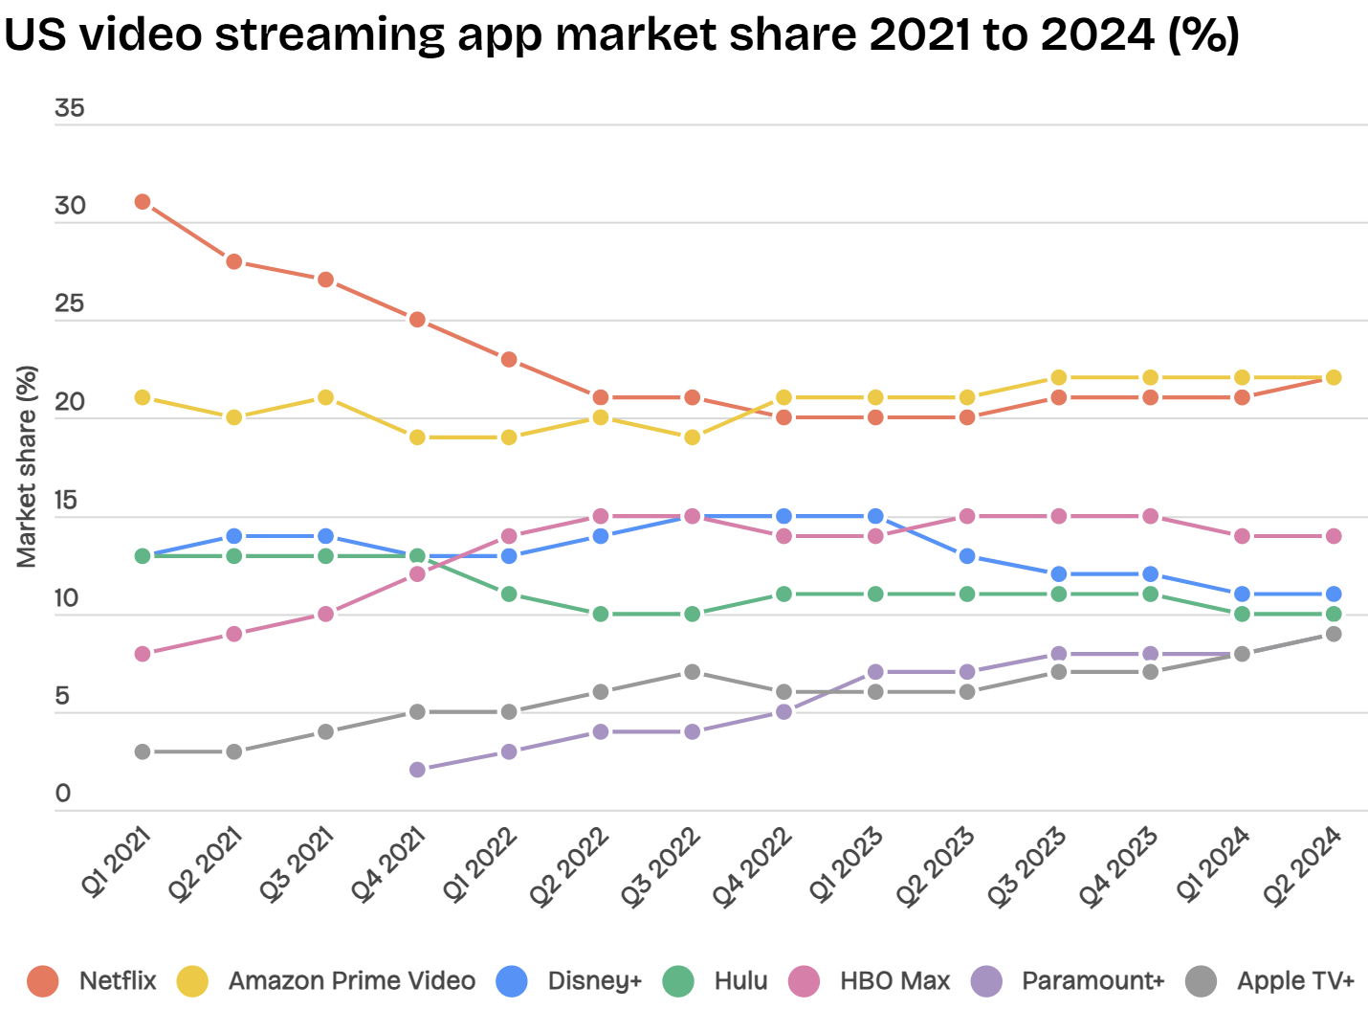

*Figure 1 Fluctuation of Video Streaming App Marketshare*

*Source: https://www.businessofapps.com/data/video-streaming-app-market/*

### 

### 

### 

### Appendix 2: Regression Results

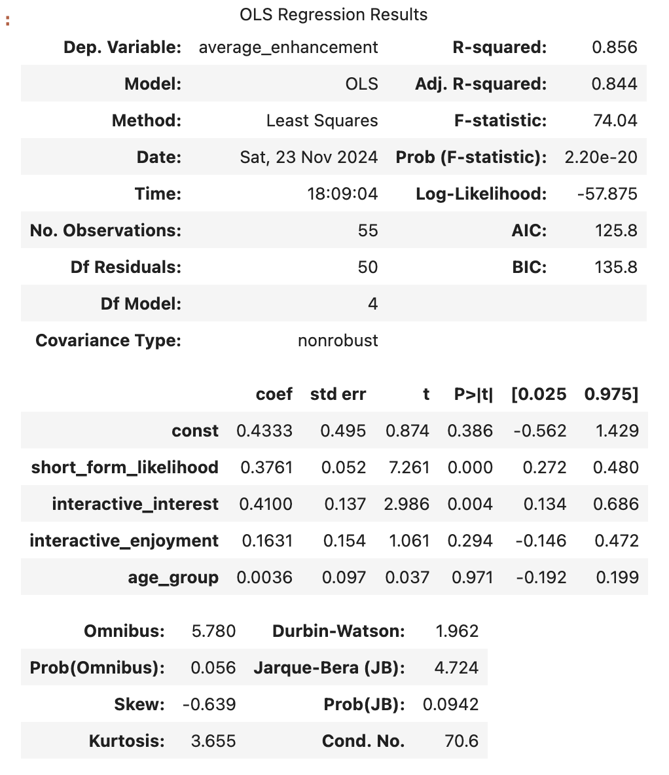

### 

### 

### 

### Appendix 3: Table 1

| **No.** | **Risk Description** | **Impact Level** | **Likelihood Level** | **Risk Priority** |
| --- | --- | --- | --- | --- |
| 1 | Low User Engagement: Short-formed and interactive content are not as engaging | High (3) | High (3) | High |
| 2 | Negative User Experience: Users find the new feature confusing | High (3) | Medium (2) | High |
| 3 | Copyright Infringement: Short-form content raises negative reviews from the content owner | Medium (2) | Small (2) | Medium |
| 4 | Increased Cost: Additional cost caused by technicals and content creation | Medium (2) | Small (1) | Small |
| 5 | Unintended Effect: The short-form content feature will further decrease attention span, limiting their ability to watch full content | Small (1) | Small (Medium) | Small |
| 6 | Technical Issues: Poor experience caused by bugs | Medium (2) | High (3) | High |
| 7 | Data Generation: Not enough data generated by the new feature | Small (1) | Small (1) | Small |
| 8 | User Fatigue: Too Much Content | Medium (2) | High (3) | Medium |
| 9 | Intuitiveness: Lack of guidance in the interactive content | Small (1) | High | Medium |

*Table 1 List of Potential Risks*

### 

### 

### Appendix 4: Table 2

| **Impact/Likelihood** | **Small (1)** | **Medium (2)** | **High (3)** |
| --- | --- | --- | --- |
| **Small (1)** | Data Generation | Unintended Effect | User Fatigue |
| **Medium (2)** | Increased Cost | Copyright Infringement | Technical Issues |
| **High (3)** | Intuitiveness | Negative User Experience | Low User Engagement |

*Table 2 Impact/Likelihood Risk Matrix*

### Appendix 5: ChatGPT Conversation for Scenario Analysis GenAI Component

https://chatgpt.com/share/673dc3a3-6178-8012-b757-23b02329d836

### Appendix 6: ChatGPT Conversation for Risk Assessment GenAI Component

https://chatgpt.com/share/673e01dc-4df0-8010-b5e7-e6ce4abee409

### Appendix 7: Survey Results

[Possibility of Implementing Short Form and Interactive Content on Netflix.xlsx](https://liveuclac-my.sharepoint.com/:x:/g/personal/uceimr5_ucl_ac_uk/EbDMP4Cp3cJFsV4dlA5o04MB_3ATUjvpw0370NyBv9ciCA?e=REOBdE)